Recon V3

MODEL FSV1132-03

USER MANUAL
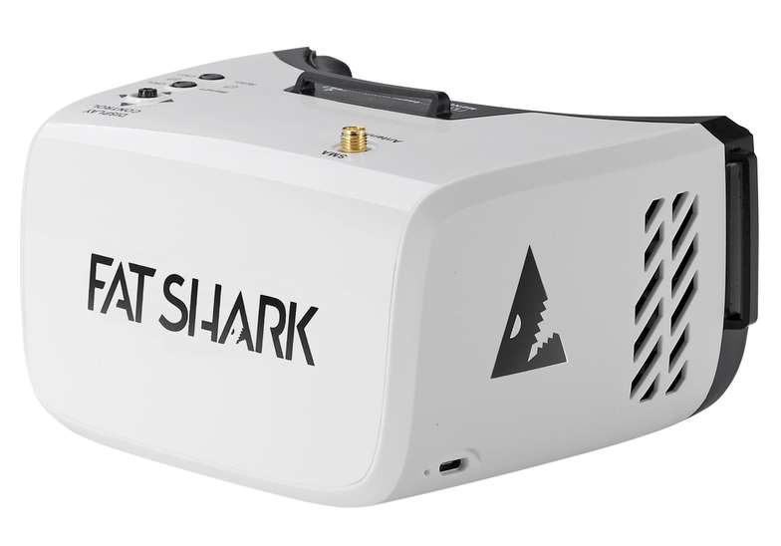

Revision A 05/24/2019

For more product information, please visit:
www.fatshark.com
All Rights Reserved

Headset Operation
- Battery Charging: The battery in the headset is a standard 18650 2600mAh Li-ion cell, and can be charged with built-in charger by connecting a micro USB power supply to the headset.

- Brightness and Contrast: Slide the 5-way button left and right or forward and back for contrast and brightness adjustment.

- Channel Selection: Short press channel Up(CH+)/ Down(CH-) button to incrementally increase/decrease the channels. Long press and release the Up(CH+) button to change band; long press and release the Up(CH-) button to do auto scan active channel.

- DVR Recording: Vertically depress the 5-way button and listen for the short beep to start and stop recording video from the live feed. Long-press the 5-way button to enter the DVR menu and browse/play content. This DVR has no auto save recording file function, need to manually stop recording to save file.

- Control Diagram:
